## Maintenance

Modern world demands efficiency and industries today are looking after designing the most suitable and economical system which demands technical enhancement. Most of the factories today are getting rid of inventory and working on JIT(Just-in-time ) model to cut down the workforce, this new inception in today’s world upbrings an issue of machine maintenance to a whole new scale and therefore it needs to be addressed effectively. Under 10 % of industrial equipment are bound to wear out because of their old age, the way machine deteriorate is not our concern but when it will be needed to replace is what we have to address and some of them are swift while other take time, it all depends upon various environmental and equipment factor but all rotary machine have some signature hidden under their working which can be resourceful for detecting the particular error and hence a maintenance process is eased by the aid of some signal marks as shown by [1].

## Methodologies

In industries, following three techniques are in practice for industrial maintenance:

• Breakdown maintenance

• Scheduled or preventive maintenance

• Predictive maintenance

## Breakdown

Breakdown maintenance refers to changing the equipment when it is worn out.

Maintenance of this type seems to save the cost of maintenance system but there are few factors which have to be kept in mind as this kind of maintenance do come up with major risks. If there is a small scale production facility with limited amount of products to be delivered in ample time and the machinery being used have separate part and misfunctioning of one sector does not relate to other, here we can implement breakdown maintenance and there is no need to inject maintenance system her but in corporate world, we have tightly scheduled production facility and even delay of an hour can be bit problematic and some misfunction left unaddressed can lead to extensive repairing than could have been needed before so in these system, we have to look for different approach.

## Scheduled

A type of maintenance where periodic inspection of machine is performed and machine is dismantled and assessed, all the worn-out part or event entire machinery is replace after certain period but this approach have several drawbacks.

Inspection and tracing the defects is cost inefficient and scheduling it at regular intervals worsen it in making financially effective. Moreover, shutting down the machine for its testing adds more to the problem.

This approach can be effective only if the anticipated span of machine’s wear and tear is accurately predicted and there is no significant financial risk incurred in its inspection but there are better alternatives to it as discussed below.

## Predictive

The name itself suggests the crux of this technique. We have different parameter which are non-linearly related to the motor working, these parameter like temperature, vibration and current have their particular signatures which are largely influenced by any change in motor working condition and therefore differences in their signature will lead us to further analysis of fault detection and predicting the estimated life of a motor.

In predictive maintenance unlike scheduled, we don’t have to parse the entire system and look for the fault rather we just detect the fault and predict how much and upto which extent system can bear and then we scheduled its repairing according to our comfort hence avoiding sudden repairing which is the case in breakdown maintenance.

In industries, now a days, predictive maintenance is being deployed as it reduce the cost which is incurred by scheduling maintenance and it also emits the issue like production inefficiency and time mismanagement which are imposed via breakdown maintenance.

## Conditional Monitoring

Faultier machine exhibit nuances in their different parameters which can be processed down to detect the fault. There are several parameters like vibration, current, temperature etc considered while estimating the machine status by deploying data analysis technique on fetched data set. We can directly detect the fault by looking at the output signal of a sensor in some cases while in most cases, we have to rely on statistical analysis technique on fetched packet of data set from Raspberry PI as noted in [7].

### Infrared Thermography

Every object above absolute zero emit thermal radiation which can’t be seen by bare eyes but there are instrument to observe it and *Thermograms* are used to plot the object temperature,

Specific to plant maintenance and condition monitoring, infrared thermography is used in applications such as:

* Monitoring the electrical and mechanical conditions of a motor
* Bearing inspections (abnormal bearing friction)
* Monitoring refractory insulation
* Locating gas, liquids and sludge levels

Abnormal heat pattern can be indicator of the fault as machines hear signature do vary if there is any noise in it but to analyze and pinpoint the fault you have to carefully understand radiometry and heat transfer analysis on it.

Some technique includes

* Spot infrared thermometers
* Infrared thermal-imaging cameras
* Infrared scanner systems.

### Radiography

This method uses radiation imaging to identify internal hardware and component flaws. Applications include inspecting castings, sintered parts, and weldments. One of the most thorough non-destructive testing methodologies is this one.

The method is based on calculating the differential radiation assimilation into the part or material, which may be measured and studied. Internal corrosion and flaws absorb various amounts of radiation.

Techniques include:

* Neutron backscatter
* Computed radiography
* Computed tomography (CT)
* Direct radiography

### MCSA

Motor current signature analysis is another critical analysis technique used to detect faults like

* Broken rotor bars
* Shorted turn in stator winding
* Airgap nonconcentric

In MCSA , current sensor are used to detect current of armature winding and other components involved to extract the signature of motor, healthy motor will definitely depict the different output than unhealthy one and then further feature extracted coupled with ML approach will detect which error to suspect.

### VIBRATION ANALYSIS

Many components in machine exhibit vibration and their pattern are distinctive. When there is fault like

* Nonconcentric air gap
* Damaged Weld/Bolts
* Broken Gear Tooths

There will be change in pattern which can be sensed through a sensor and crew member know that different fault leads to different pattern and these patterns can be used to perform vibration analysis.

While purchasing sensor for vibration analysis, we have to keep in notice the frequency range of sensors as uncertainty can be dealt with sensor fusion technique but there is no way to deal with frequency range once it is purchased.All this have been covered in [2][5]

## FEATURE EXTRACTION TECHNIQUE

Feature extraction techniques are applied on raw signal most probably in time domain to extract the certain feature of signal out of it which are proportional to the changes in consideration thus making ease in designing a model of system.

(TO BE LISTED HERE)[4][6]

## KALMAN FILTER

*“Also known as linear quadrative estimation is an algorithm that use series of input along with a signal noise and accuracies and predict the output estimate better than that of single measurement alone”*

Sensor for collecting data of signal do possess some in accuracies which are preferable to be removed for better model design. These uncertainties in reading can be decreased significantly by using sensor fusion via Kalman filtering as studied in Li, Q. *et al.* [8].

Kalman filtering can be used for different purpose in different application but in our context, we will be only referring to it for lessening the uncertainties in our sensor by influencing the calculated value by the prediction which is actually made via other sensor values. Details of it will be explained separately.

## MACHINE LEARNING APPROACH

Designing a system which can learn and train to extract information from statistical data and draw pattern out of it is what is known as Machine learning. Different models are proposed and there are used keeping in view the application we are plugging in.

There are three different types of learning technique used:

* Supervised
* Unsupervised
* Reinforcement Learning

### Unsupervised learning

This approach is used when dataset are unlabeled and machine itself would derive relation between different elements in data set. Here external interference is not involved and unlike supervised learning, we don’t train model knowing in advance output of dataset.

### Supervised

Standing quite in contrast to Unsupervised approach, we deal with labelled data set in this class and we train models by using already tested dataset with define output.

In our case, this approach seems reasonable as we have to inject fault by our selves in first place and then we will testify our data.

### Reinforcement

Reinforcement learning is somewhat different to that of supervised in a sense that we will reward some behaviors of data set and we will punish some behaviors to train our model. It is used when we want to perceive our environment and learn through trial-and-error approach.

Several models of all three-training approach have been devised. Mathematical models are different statistical technique used to calculate the output. Figure2.1 summarize the whole discussion

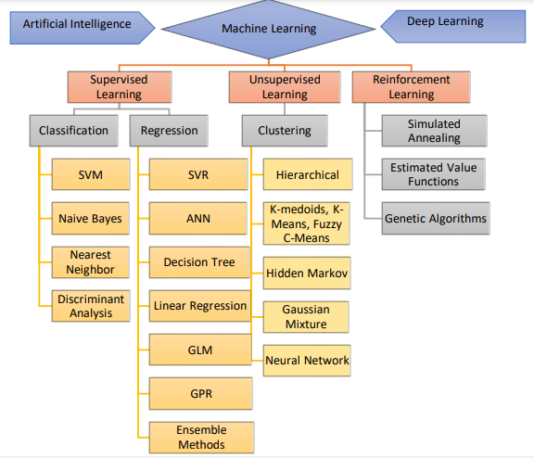

Figure 2.1 Hierarchy of ML approach

We will consider model of our concern

### Artificial Neural Network

Last year,our apparatus was modelled using logistic regression approach where two different sensors were used to capture two bearing vibration signatures but the drawback of logistic regression is that it gives output in form of pass / fail and this year,we will inject more faults into our system which will become a bit problematic therefore we have to move on to a more advance technique called ANN.

There is a lot to discuss about this technique but we will stick to its general overview.

ANN is composed of multiple layers. Each layer corresponds to particular pattern of the output and as we move further in to the layers,we are drawing close to the output pattern.Each layer contain nodes which contain weights,each weight can either be constant value or function which is limited to value between 0 and 1 using sigmoid function and biases are also further added.

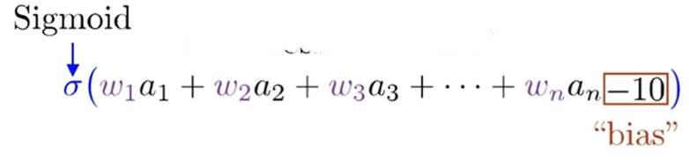

So, ANN modelling comprises of multiple datasets which will adjust all the weight and biases to conform with given output. One more interesting thing to discuss is that sometimes we obtain multiple outputs instead of one and here cost function comes into play which act as output layer on all the calculations discussed before.

In context to our FYP, input to model will be processed signal and output will be an error out of many suspected.

**REFERENCES**

[1]Çınar, Z.M. *et al.* (2020) *Machine learning in predictive maintenance towards Sustainable Smart Manufacturing in industry 4.0*, *MDPI*. Multidisciplinary Digital Publishing Institute. Available at: http://dx.doi.org/10.3390/su12198211 (Accessed: November 1, 2022).

[2] B. Christiansen, “Complete List of Condition Monitoring Techniques,” MRO Mach. Equip.,

pp. 1–9, 2019, [Online]. Available: https://www.mromagazine.com/features/completelist-of-condition-monitoring-techniques.

[3] J. E. Berry, “Predictive Maintenance and Vibration Signature Analysis I,” Columbus, OH,

IRD Mechanalysis, Inc, 1993.

[4] R. N. Bracewell, “The fourier transform,” Sci. Am., vol. 260, no. 6, pp. 86–95, 1989.

[5] A. Nandi and H. Ahmed, Condition Monitoring with Vibration Signals, First. Brunel

University London, UK, 2019.

[6] E. Bechhoefer and M. Kingsley, “A review of time synchronous average algorithms,” in

Annual Conference of the PHM society, 2009, vol. 1, no. 1.

[7] J. Chebil, M. Hrairi, and N. Abushikhah, “Signal analysis of vibration measurements for

condition monitoring of bearings,” Aust. J. Basic Appl. Sci., vol. 5, no. 1, pp. 70–78, 2011.

[8] Li, Q. *et al.* (2015) “Kalman filter and its Application,” *2015 8th International Conference on Intelligent Networks and Intelligent Systems (ICINIS)* [Preprint]. Available at: https://doi.org/10.1109/icinis.2015.35.